**Welcome Back Turtle Assignment:**

1. 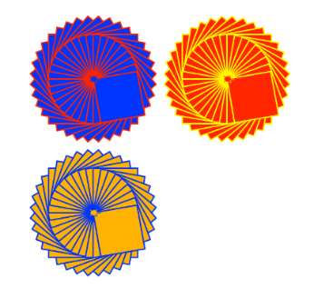Create a Python Turtle program to do the following:
2. Draw an interesting shape using multiple basic shapes   
   and pen colors.
3. Use the **goto(x,y)** function to move the starting point for the shape   
   to a different location on the output window.
4. Use a **counted loop** to draw multiple copies of your shape at different   
   positions on the output window.
5. Use the **input()** function to ask for a number of times to repeat the shape. Use this number to control the repeat of the counted loop.
6. Extension. Check the repeat number input to make sure it is a valid number and that it is between the range of 1 to 6 repeats.
7. Use print screen to copy and paste an image of your program output below.
8. Provide a listing of your Python program below.